Tenant Policy Actual Screens Guide
Angular UI ke asli screenshots ke saath click → API → response → database table. 22 September 2026 code inspection. Angular project read-only raha; production API ya DB ko is document ke liye call nahi kiya.
Is guide ko kaise padhein: blue UI screenshot dekhein, uske neeche usi button ka route aur table dekhein. “Response” ka matlab API ka data; “table” ka matlab database mein saved row. Red font mein wahi gaps hain jo code/screenshot se verify hue.

Sabse chhota flow
Policy Type = Annual Leave ka reusable naam. Policy = India Permanent Annual Leave ka actual record. Policy Version = us record ka v1 Draft/Published. Rule = kya likha hai. Applicability = kin employees par lagegi. Assignment = kisi employee ko direct policy dena. Resolve = employee/date ke liye Published policy ka answer.
Policy Types → Policy Definitions Create → Submit → Approve → Publish → Resolve. Documents, Assignments, Exceptions, Acknowledgements, Approval progress, Audit = Policy Version ke andar tabs, alag main menu screens nahi.
GAP — UI Employee/get-all string employeeId (jaise 1OZ8MZRL) deta hai. Resolve/Assign/Exception UI Number(id) banata hai; backend long employeeId expect karta hai. Is identity mismatch ko fix/test kiye bina real employee flow ko working assume na karein.

Policy Types list
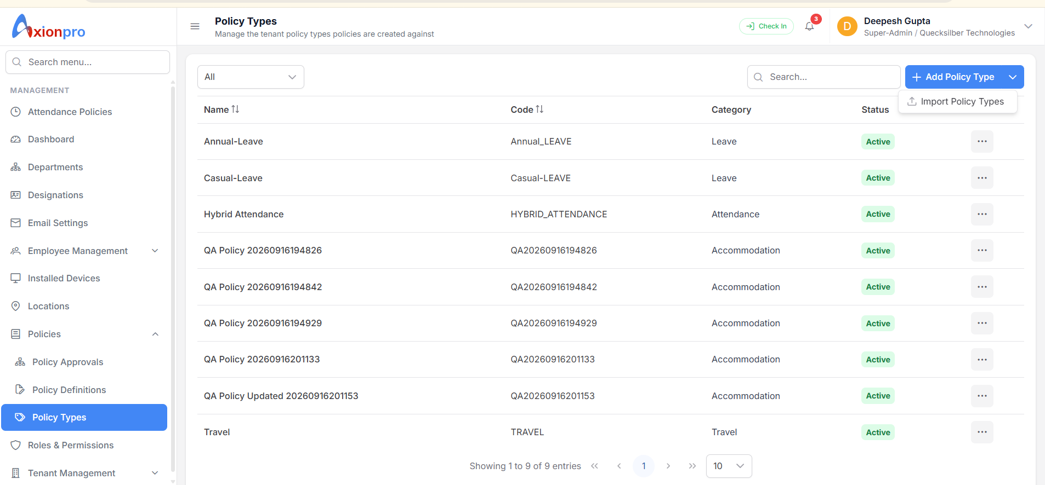
Yahan tenant reusable type banata hai. Screenshot mein Annual-Leave, Casual-Leave, Hybrid Attendance aur Travel dikhte hain. Category dropdown ka data PolicyCategory lookup se aata hai.

Is screen par click karne se kya hota hai
List load API: GET /api/TenantPolicy/types + GET /api/TenantPolicy/lookups | Result/table: data = type rows + categories; read PolicyType, PolicyCategory
Add Policy Type API: POST /api/TenantPolicy/types; body policyTypeCode, policyName, policyCategoryId, defaultCurrencyCode | Result/table: data = created {id,code,name,categoryId,...}; INSERT PolicyType
Edit / Deactivate API: PUT /types/{id} / PATCH /types/{id}/status | Result/table: updated type / boolean; UPDATE PolicyType
Import Policy Types API: /api/TenantPolicy/bulk/types/template, preview, confirm, jobs, report | Result/table: valid rows → PolicyType; failed rows report
GAP — Type create hone se Policy/PolicyVersion/employee leave balance create nahi hota. Screenshot ke QA types ko real business types na samjhein.

Policy Definitions list
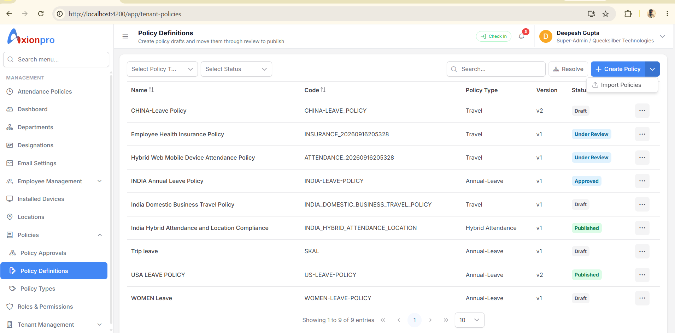
Yeh actual named policies ki list hai. Har row mein naam, code, policy type, latest version aur status. Filter Type/Status/Search se list API dobara chalti hai.

Is screen par click karne se kya hota hai
List load API: GET /api/TenantPolicy?pageNumber=1&pageSize=10&policyTypeId=...&statusId=...&search=... | Result/table: data = [{id,code,name,policyTypeId,currentVersionId,versionNumber,status}], totalRecords; READ Policy + PolicyVersion
Create Policy API: POST /api/TenantPolicy | Result/table: data = full policy detail with versionId/rules/applicability; INSERT Policy, PolicyVersion, PolicyRule, PolicyApplicability, PolicyChangeAudit
Edit draft API: PUT /api/TenantPolicy/{policyId}/versions/{versionId} | Result/table: full detail; UPDATE Policy/PolicyVersion, REPLACE child Rule/Applicability rows
Open workspace API: Angular navigation /app/tenant-policies/{policyId}/versions/{versionId} | Result/table: read detail; no insert
Import Policies API: /api/TenantPolicy/bulk/definitions/... | Result/table: confirmed valid rows create Policy + Version and children
GAP — Screenshot mein China Leave, Insurance aur Hybrid Attendance rows ka Policy Type “Travel” dikh raha hai. Type Policy.PolicyTypeId se aata hai; names dekhkar correct mapping assume na karein. Actual row IDs verify karke data correct karna hoga.

Create Policy form ke andar Rule aur Applicability
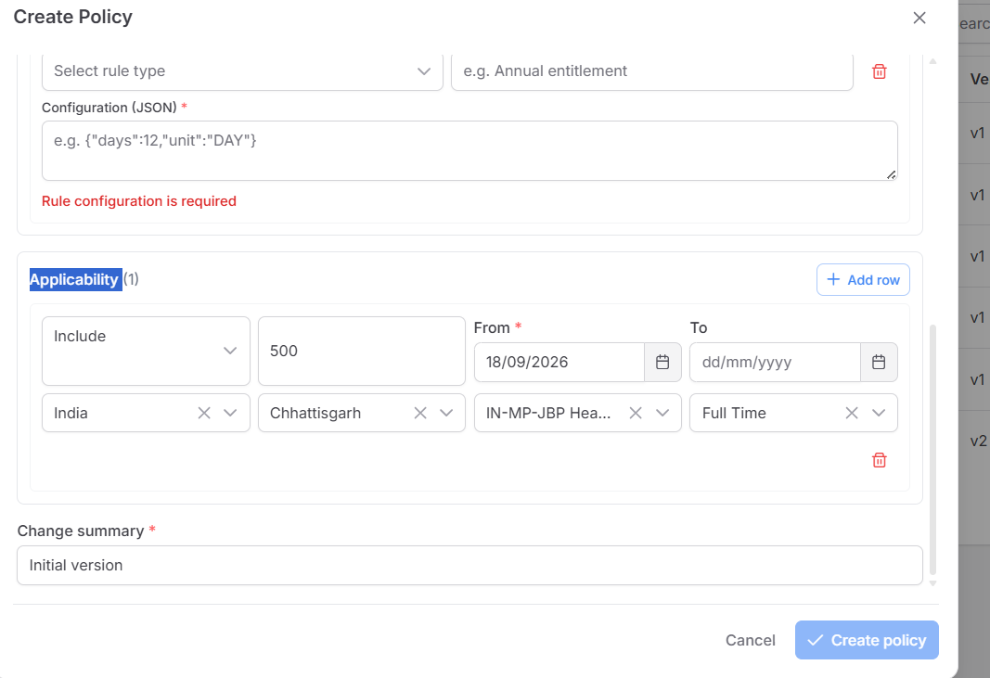
Create Policy popup ka neeche wala hissa. Rule ka matlab “kya terms hain”; Applicability ka matlab “kin employees par”. Owner Department top field policy ka owner hai; target Department applicability mein alag field hai.

Is screen par click karne se kya hota hai
Rule add API: POST /api/TenantPolicy body rules:[{policyRuleTypeId,ruleName,ruleOrder,ruleConfiguration}] | Result/table: PolicyRule rows; ruleConfiguration JSON object ka STRING, e.g. {"days":18}
Applicability add API: same POST body applicability:[{applicabilityMode,countryId,stateId,tenantLocationId,employeeTypeId,priority,effectiveFrom,...}] | Result/table: PolicyApplicability rows; 1 Include / 2 Exclude
Create Policy API: POST /api/TenantPolicy; top + rules + applicability ek body | Result/table: response data = policy detail; all 4 core tables in one creation
GAP — Raw JSON ka syntax valid hona business calculation ka proof nahi. Generic resolver ruleConfiguration se leave days, balance, attendance ya insurance payout calculate nahi karta. Work arrangement/employment-status selector UI mein nahi, although backend fields exist.

Effective Policies popup
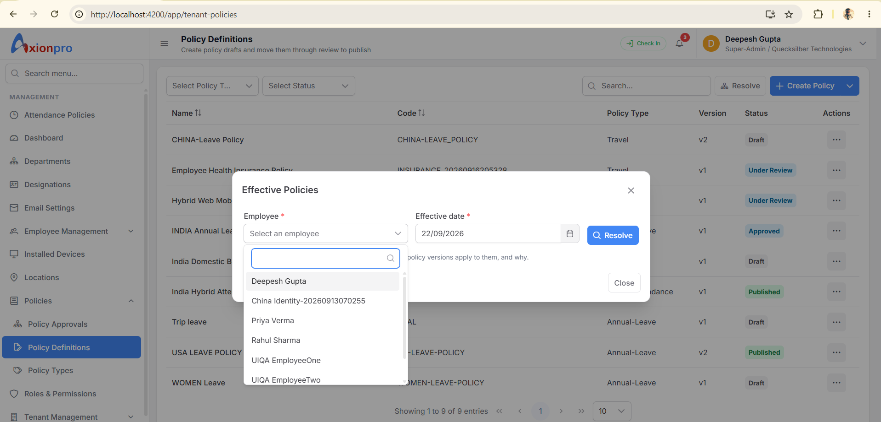
Definitions list ka Resolve button. Employee aur effective date chuniye. Ye preview hai: “is tareekh ko is employee par kaunsi Published policy lagti hai?”

Is screen par click karne se kya hota hai
Resolve API: GET /api/TenantPolicy/resolve?employeeId={numericId}&effectiveDate=YYYY-MM-DD | Result/table: data = [{policyId,policyVersionId,policyCode,policyName,priority,resolutionSource}]; READ Published PolicyVersion + Applicability + Assignment + employee location; WRITE kuch nahi
GAP — Employee dropdown public string employeeId deta hai; Number(id) non-numeric par fail hota hai. Resolve empty data ka matlab us date par matching Published policy nahi; automatic assignment row ka absence nahi.

Policy Approvals
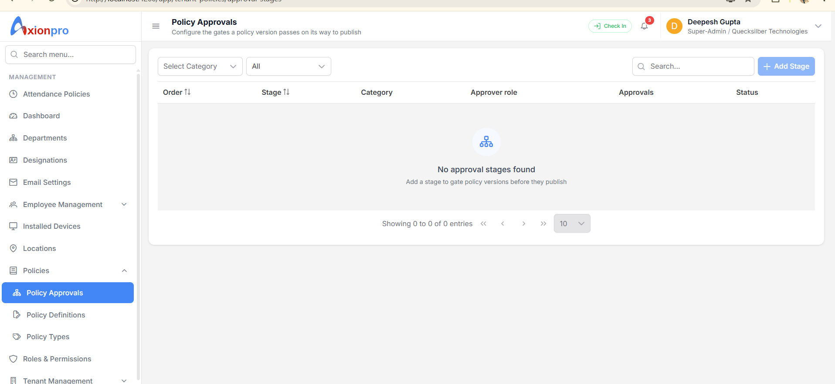
Yeh screen approval ka route/gate configure karti hai. Screenshot mein zero stage dikh raha hai. Stage banana aur policy approve karna do alag kaam hain.

Is screen par click karne se kya hota hai
List API: GET /api/TenantPolicy/approval-stages | Result/table: data = [{id,policyCategoryId,stageName,stageOrder,approverRoleId,minimumApprovals,isMandatory,isActive}]; READ PolicyApprovalStage
Add Stage API: POST /api/TenantPolicy/approval-stages | Result/table: INSERT PolicyApprovalStage; policyCategoryId null = all categories
Edit / Disable API: PUT /approval-stages/{id} / DELETE /approval-stages/{id} | Result/table: UPDATE/disable PolicyApprovalStage; prior history retained
Actual Approve API: Definitions row → POST /versions/{versionId}/transition action APPROVE | Result/table: PolicyApprovalHistory if mandatory stages; PolicyVersion may become Approved
GAP — Screenshot mein stage blank hai. Backend mandatory stage na hone par Under Review → Approve direct Approved kar sakta hai; multi-person gate chahiye to stages configure/test karna hoga.

Policy lifecycle buttons
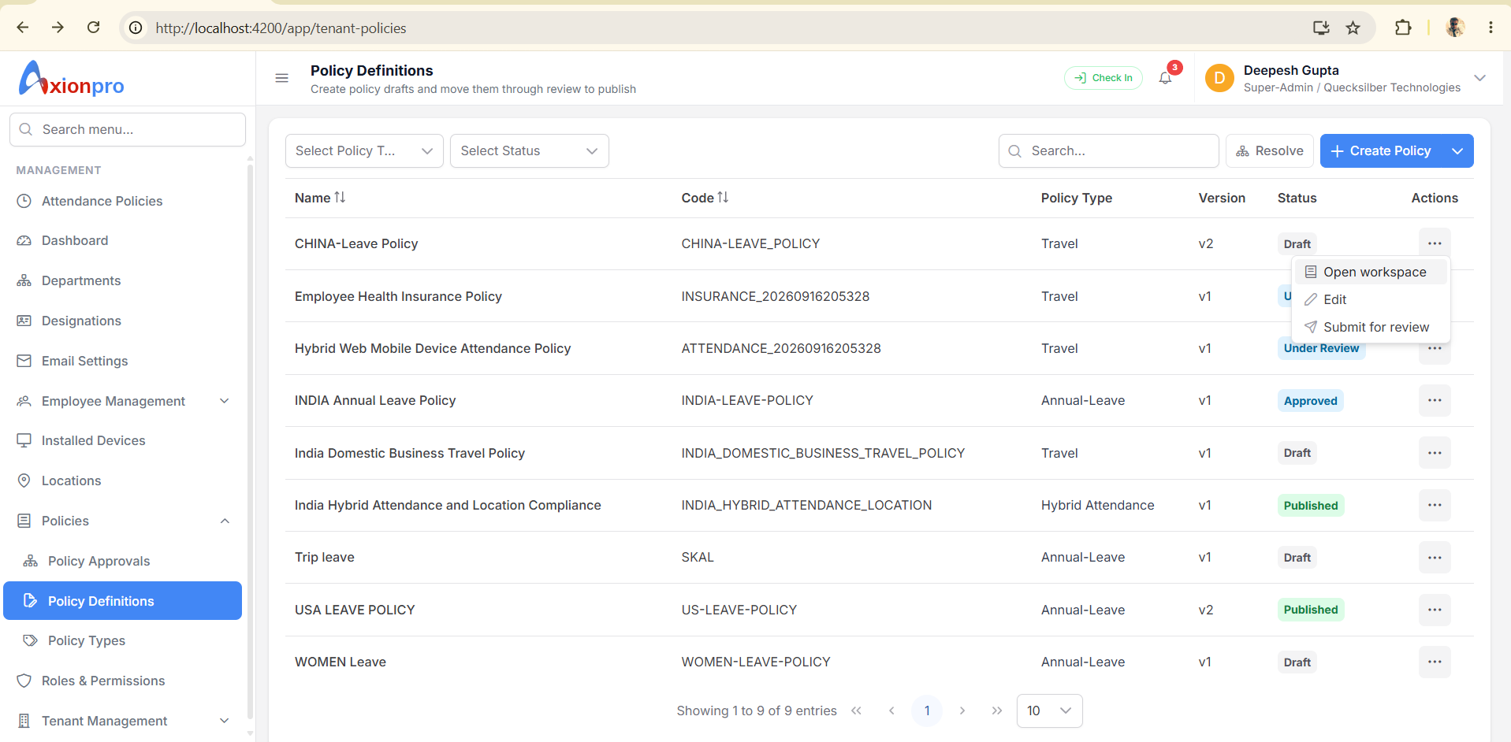
Definitions row ka menu status ke hisaab se badalta hai. Create ke baad Draft, fir Under Review, Approved, Published. Sirf Published/current/date-valid version Resolve mein milta hai.

Is screen par click karne se kya hota hai
Submit for review API: POST /api/TenantPolicy/versions/{versionId}/transition; action SUBMIT | Result/table: PolicyVersion status Under Review + PolicyChangeAudit
Approve / Reject API: same API; action APPROVE / REJECT | Result/table: PolicyApprovalHistory if stages configured; PolicyVersion status; audit
Publish API: same API; action PUBLISH | Result/table: PolicyVersion Published + IsCurrent=true; previous current unset; audit
Archive API: same API; action ARCHIVE | Result/table: PolicyVersion Archived + IsCurrent=false; audit
GAP — Approved status ko Published samajhkar employee ke liye active mat maanien. Publish alag click hai.

Policy Version Documents
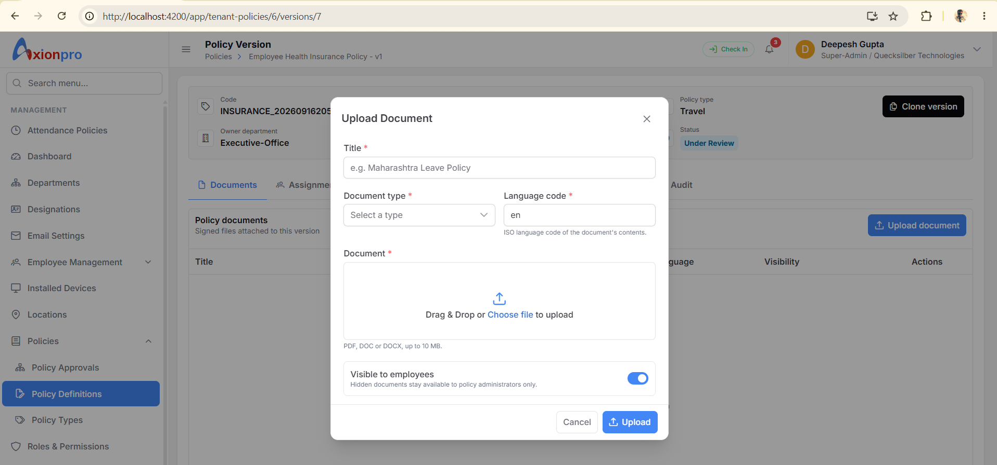
Workspace ka Documents tab. Document Type dropdown /lookups se. File binary object storage mein, uski metadata PolicyDocument row mein.

Is screen par click karne se kya hota hai
List API: GET /api/TenantPolicy/versions/{versionId}/documents | Result/table: data = [{id,title,originalFileName,languageCode,isEmployeeVisible,url}]; READ PolicyDocument
Upload API: POST /api/TenantPolicy/documents multipart file,policyVersionId,policyDocumentTypeId,documentTitle,languageCode,isEmployeeVisible | Result/table: data = document object; INSERT PolicyDocument + upload object
Open / Delete API: temporary url / DELETE /api/TenantPolicy/documents/{documentId} | Result/table: Open read only; Delete soft-delete PolicyDocument + stored file action
GAP — Published/Archived version par backend document mutation allow nahi karta. URL temporary hai; permanent link ke roop mein save na karein.

Policy Version Assignments
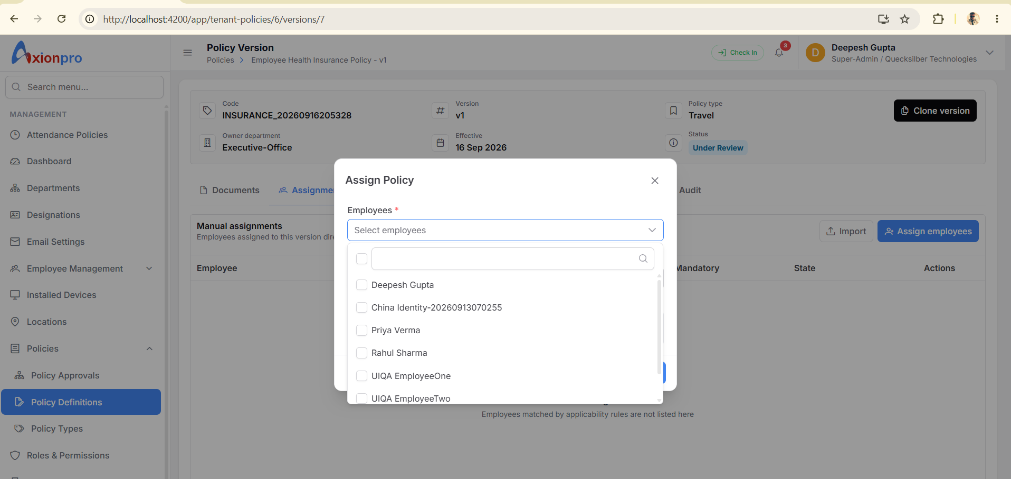
Assignments tab manual assignments dikhata hai. Applicability se automatically matched employees yahan list nahi hote. “No manual assignments” ka matlab policy kisi par nahi lagegi, aisa nahi.

Is screen par click karne se kya hota hai
List API: GET /api/TenantPolicy/versions/{versionId}/assignments | Result/table: data = manual assignment rows; READ PolicyAssignment
Assign employees API: POST /api/TenantPolicy/assignments; policyVersionId,employeeIds:[numeric],effectiveFrom,effectiveTo,isMandatory | Result/table: data = {inserted,existing}; INSERT/reactivate PolicyAssignment + missing PolicyAcknowledgement
Remove / Import API: DELETE /assignments/{id}; /bulk/assignments/... | Result/table: assignment inactive / bulk valid rows assigned
GAP — Only Published version assignable. UI selected string IDs ko Number(id) banata hai; real alphanumeric employee IDs drop ho sakte hain. Import address-bar version se restricted nahi: file mein policy/version per row aata hai.

Policy Version Exceptions
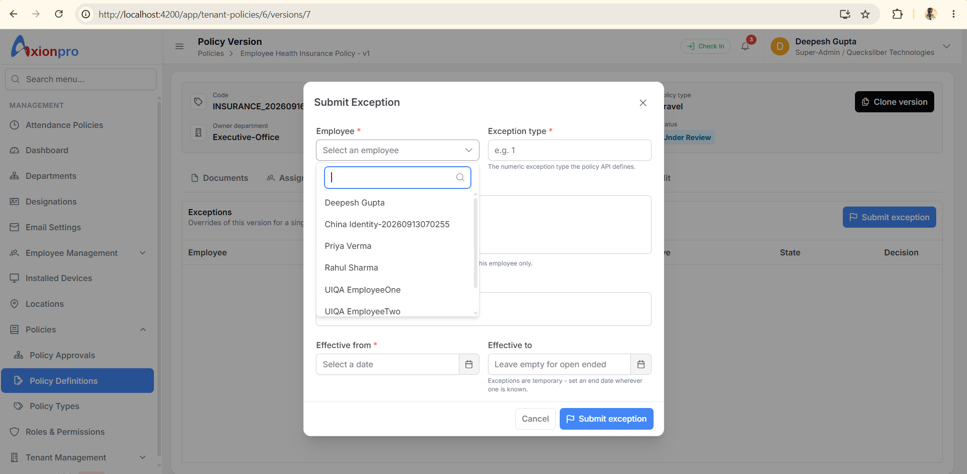
Exceptions tab ek employee ki temporary override request rakhta hai. Example: special period ke liye alag terms. Ye policy-wide Rule edit nahi hai.

Is screen par click karne se kya hota hai
Submit exception API: POST /api/TenantPolicy/exceptions; employeeId,policyVersionId,exceptionType,overrideConfiguration,reason,effectiveFrom,effectiveTo | Result/table: data = new exception ID; INSERT PolicyException
Approve / Reject exception API: POST /api/TenantPolicy/exceptions/{id}/decision; approve true/false | Result/table: data = boolean; UPDATE PolicyException approvalStatusId
List API: GET /api/TenantPolicy/versions/{versionId}/exceptions | Result/table: data = exception rows; READ PolicyException
GAP — Exception type UI numeric input hai, meaningful label/enum select nahi. Employee ID mismatch yahan bhi hai. Stored overrideConfiguration ko actual payroll/leave execution maan kar na chalayein.

Policy Version Clone and Audit
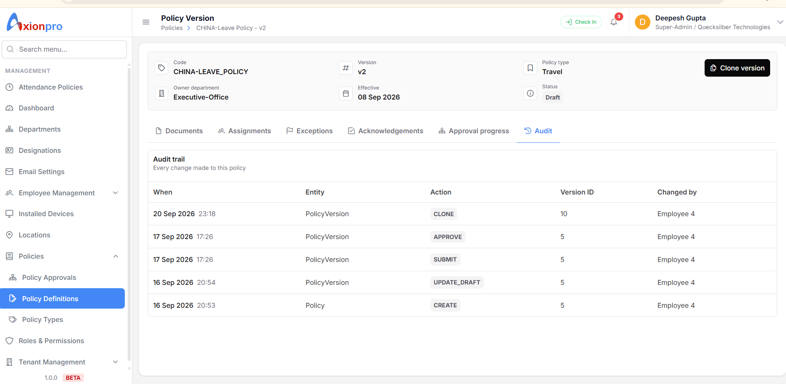
Workspace mein Clone se naya Draft version banta hai. Audit tab policy ke sab versions ki changes dikhata hai; sirf current version ki nahi.

Is screen par click karne se kya hota hai
Clone API: POST /api/TenantPolicy/{policyId}/versions/clone; sourceVersionId,effectiveFrom,changeSummary | Result/table: data = new versionId; INSERT PolicyVersion, copy PolicyRule + PolicyApplicability, audit
Audit API: GET /api/TenantPolicy/{policyId}/audit | Result/table: data = [{entityName,actionName,policyVersionId,changedById,changedDateTime,...}]; READ PolicyChangeAudit
Approval progress tab API: GET /api/TenantPolicy/versions/{versionId}/approval-progress | Result/table: data = stageId,minimumApprovals,approvalCount,isComplete; READ Stage + History
Acknowledgements tab API: GET /versions/{versionId}/acknowledgements; POST /acknowledgements for signed-in user | Result/table: READ/UPDATE PolicyAcknowledgement
GAP — Workspace URL versionId leta hai, par header GET /{policyId} se current/latest version fetch karta hai. Purana version URL kholne par header aur tabs alag versions ke ho sakte hain. Clone documents/assignments copy nahi karta.

Ek actual business example
HR ko 1 October se India ke Permanent employees ke liye 18 day annual leave terms record karne hain.
Policy Types → Leave category mein Annual Leave type existing hai to select karein; warna Add Type. PolicyType row banta hai. Abhi employee ko kuch assign nahi hua.
Policy Definitions → Create Policy: India Permanent Annual Leave; Rule “Annual entitlement”, JSON string {"days":18,"unit":"DAY"}; Applicability Include India + Permanent + 1 October. Policy + v1 Draft + Rule + Applicability rows bante hain.
Draft row → Submit; approver → Approve; Approved row → Publish. Tabhi current Published version Resolve mein aayega.
Effective Policies → ek valid employee + 1 October select. Response mein policy aaye to source APPLICABILITY. PolicyAssignment row automatically nahi banti.
Special employee ko direct dena ho to Assignments tab. Leave balance 18 credit karna generic Policy Rule save/Resolve API ka kaam nahi; uski separate business integration verify karni hogi.

Abhi kya missing ya broken hai
GAP — Employee identity mapping: string public employeeId vs numeric policy employeeId. Highest priority fix/test.
GAP — Screenshots mein Insurance/Attendance ka Policy Type Travel hai. DB PolicyTypeId mapping verify/correct.
GAP — Old version ke liye version-scoped detail/read screen missing; current header wrong version dikha sakta hai.
GAP — Automatic applicability se matched employees ka bulk coverage preview/list nahi; Resolve one employee/date hai.
GAP — Employee self-service “My Policies” dedicated route nahi mila; acknowledgement workspace mein signed-in employee ke liye hai.
GAP — Policy Rule ka raw JSON business schema/help aur exception type label missing. Valid JSON means calculated benefit nahi.
Source: Angular tenant-policies routes/components/service/interfaces; API TenantPolicyController; GenericPolicyDTOs; GenericPolicyRepository; GenericPolicyEntities. Request IDs actual menu/lookups se dynamically len. This was code inspection, not a deployed smoke test.

